Third District Court
Salt Lake County, State of Utah

UTAH FOREIGN JUDGMENT ACT

Under 78B-5-301 UCA entitled “Utah Foreign Judgment Act” the following items are necessary in order to file a judgment under this act:
1. A certified copy of the judgment with an attached exemplification certificate. A transcript/abstract of judgment, or a docket text is not acceptable.
2. A $35.00 filing fee, made payable to Third District Court.
3. A notarized affidavit stating the last known addresses of the judgment debtor and creditor.
4. A notice of judgment form. Please fill out the top portion. We will fill out the certificate of mailing, since the clerk of the court must do the mailing. An addressed stamped envelope must be enclosed for use in mailing to the debtor. Please put at least 2 stamps on the envelope.
5. If you are out of state and/or mailing the judgment to us, please include a self-addressed stamped envelope for yourself so that we can return your receipt, which contains your case number. Please use the case number we assign on all further pleadings.
6. Pursuant to UCA §78B-5-201, you must fill out and submit a Judgment Information Statement (available at https://www.utcourts.gov/howto/judgment/) in order to perfect a lien on the real property of the debtor.
7. You will also need to record your judgment and judgment information statement with the Salt Lake County Recorder’s office, in order to create a lien on real property. [See UCA §78B-5-202]

No process for the enforcement of the judgment may issue until 30 days after the judgment is filed and notice mailed out to the debtor.
If you have any questions, please call us at (801) 238-7150.
450 South State Street, Salt Lake City, Utah 84111, (801) 238-7300.

A sample exemplification certificate appears on the next page.
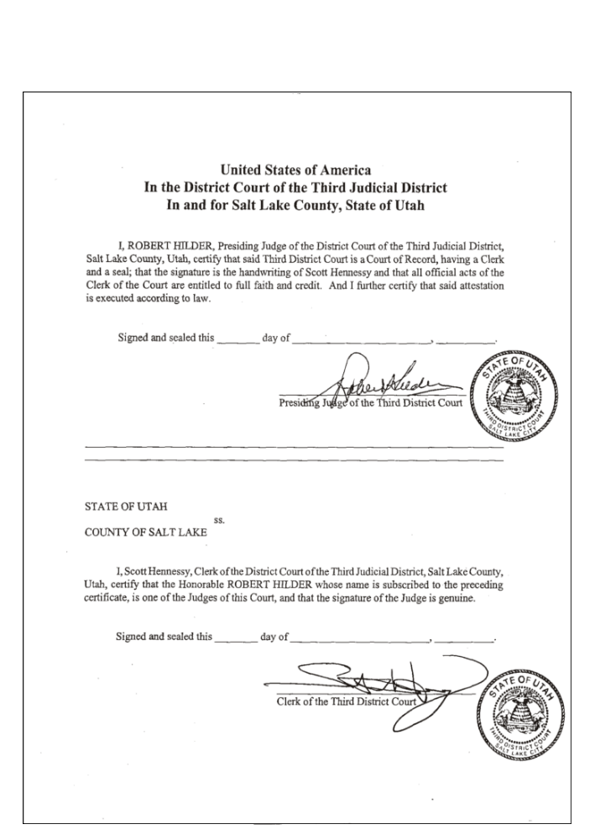
IN THE THIRD JUDICIAL DISTRICT COURT OF UTAH
IN AND FOR SALT LAKE COUNTY

________________________________
Plaintiff NOTICE OF JUDGMENT
vs.
CASE NO.________________
________________________________
Defendant

PLEASE TAKE NOTICE that the judgment filed from ___________________________
______________________ jurisdiction has been filed in the 3RD JUDICIAL DISTRICT COURT OF UTAH under the provisions of the UTAH FOREIGN JUDGMENT ACT (UCA 78B-5-301). Under this act, THIS JUDGMENT HAS THE SAME LEGAL FORCE AND EFFECT AS A JUDGMENT RENDERED BY THE UTAH STATE COURT.

____________________________ ________________________________
Date Atty or Creditor Signature

NAME & ADDRESS OF JUDGMENT NAME & ADDRESS OF CREDITOR'S
CREDITOR ATTY (if any)

________________________________ ________________________________
________________________________ ________________________________
________________________________ ________________________________

CERTIFICATE OF SERVICE BY MAILING
STATE OF UTAH
COUNTY OF
____________________, being first duly sworn, upon oath states that he/she has mailed a copy of the notice of judgment to the judgment debtor:
________________________________ (name of judgment debtor)
at ________________________________ (address)
________________________________

this _______ day of _________________, 20_____.
________________________________
Deputy Clerk

